**Assignment 1**

**Task 1: Creation of tables in hive and Importing data from Sql.**

**Importing accounts table from loudacre database to hive under the name of accounts_ak0850 table.**

Ran the following script to ensure all services are running and checked the existence of databases and tables in hive.

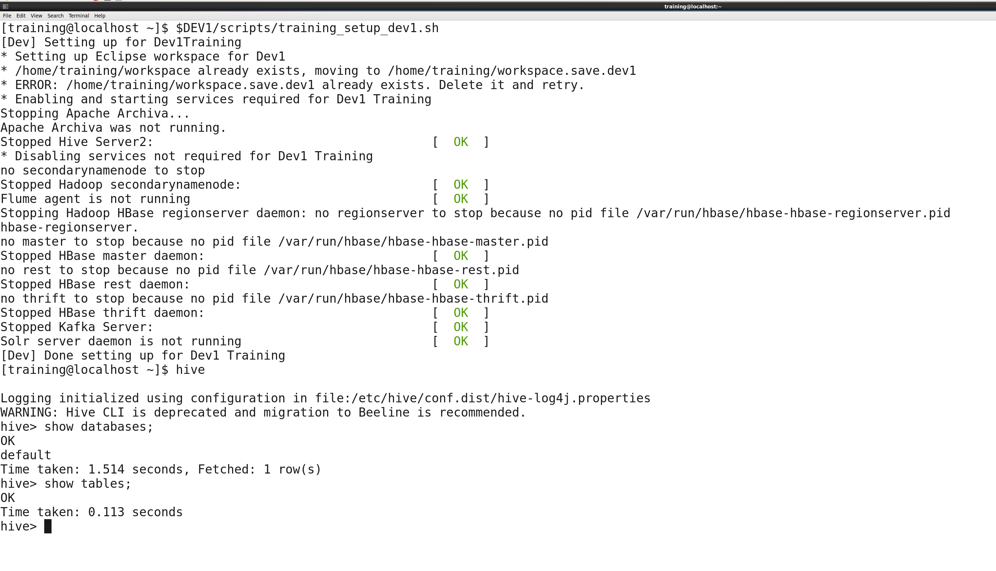

Creation of “**Assignment1”** database in Hive.

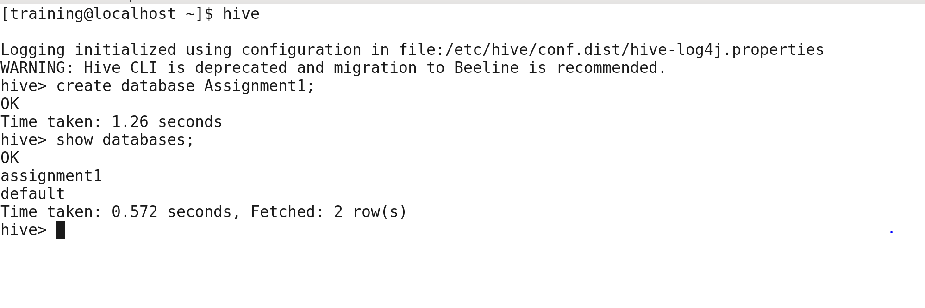

Below is the screenshot of sqoop command that creates hive table **accounts_ak0850** along with data in Hive.

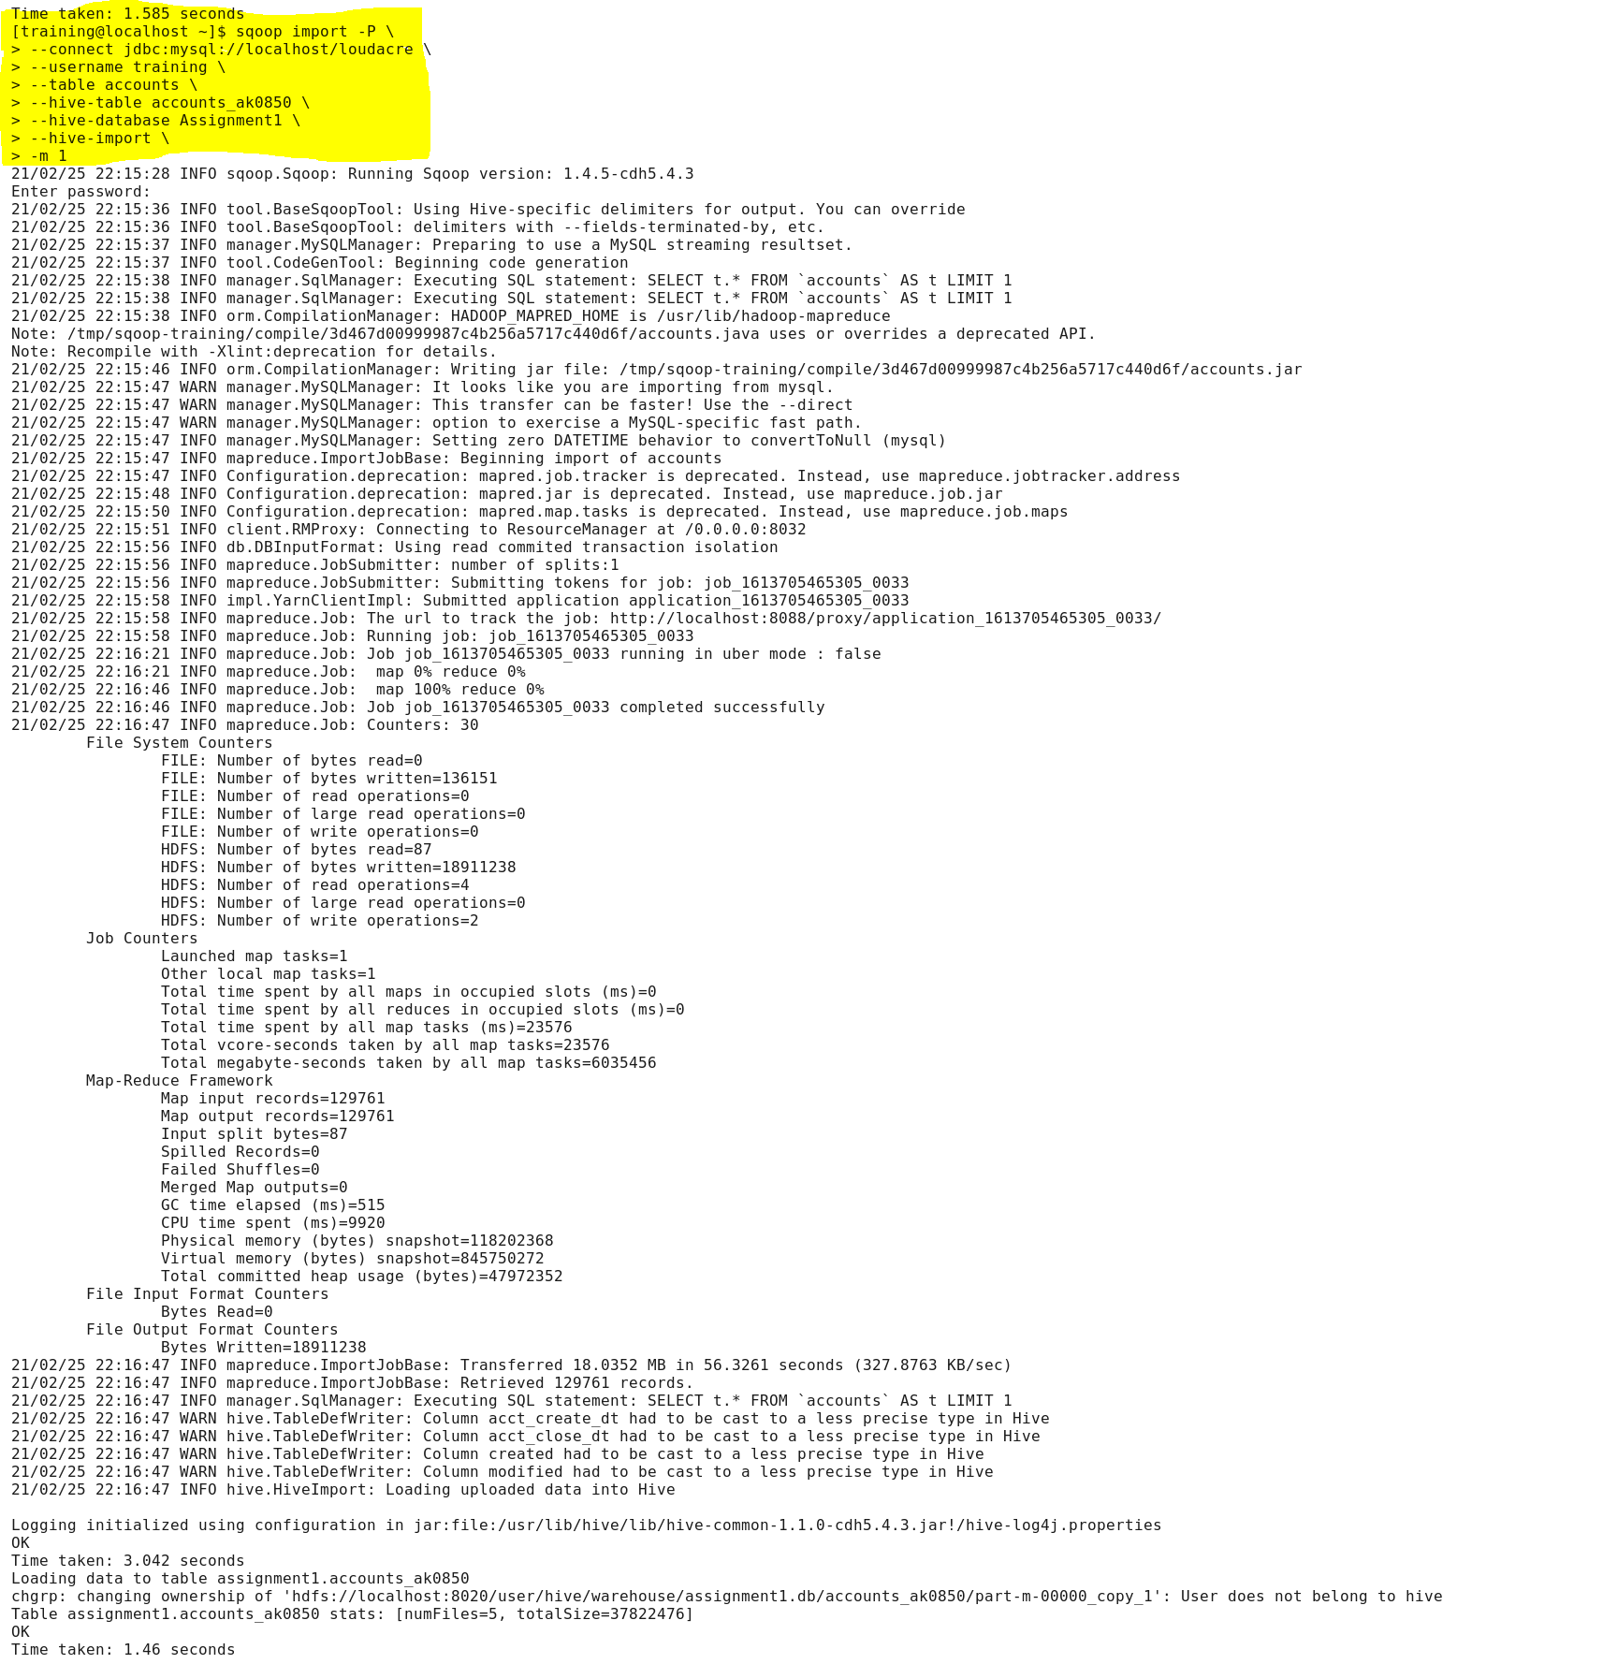

Validation of table creation accounts_ak0850 in Assignment1 hive database.

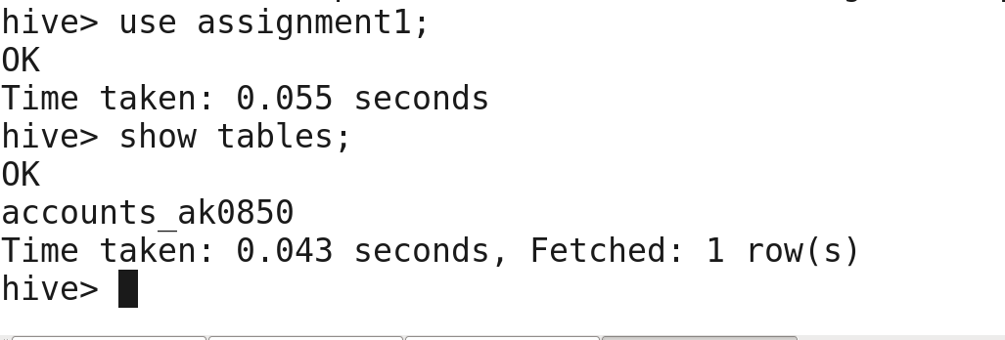

Validation of accounts_ak0850 table data in hive by displaying 10 records.

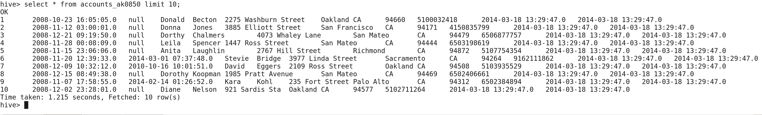

Validation of accounts_ak0850 record count with accounts table record count in MySQL.

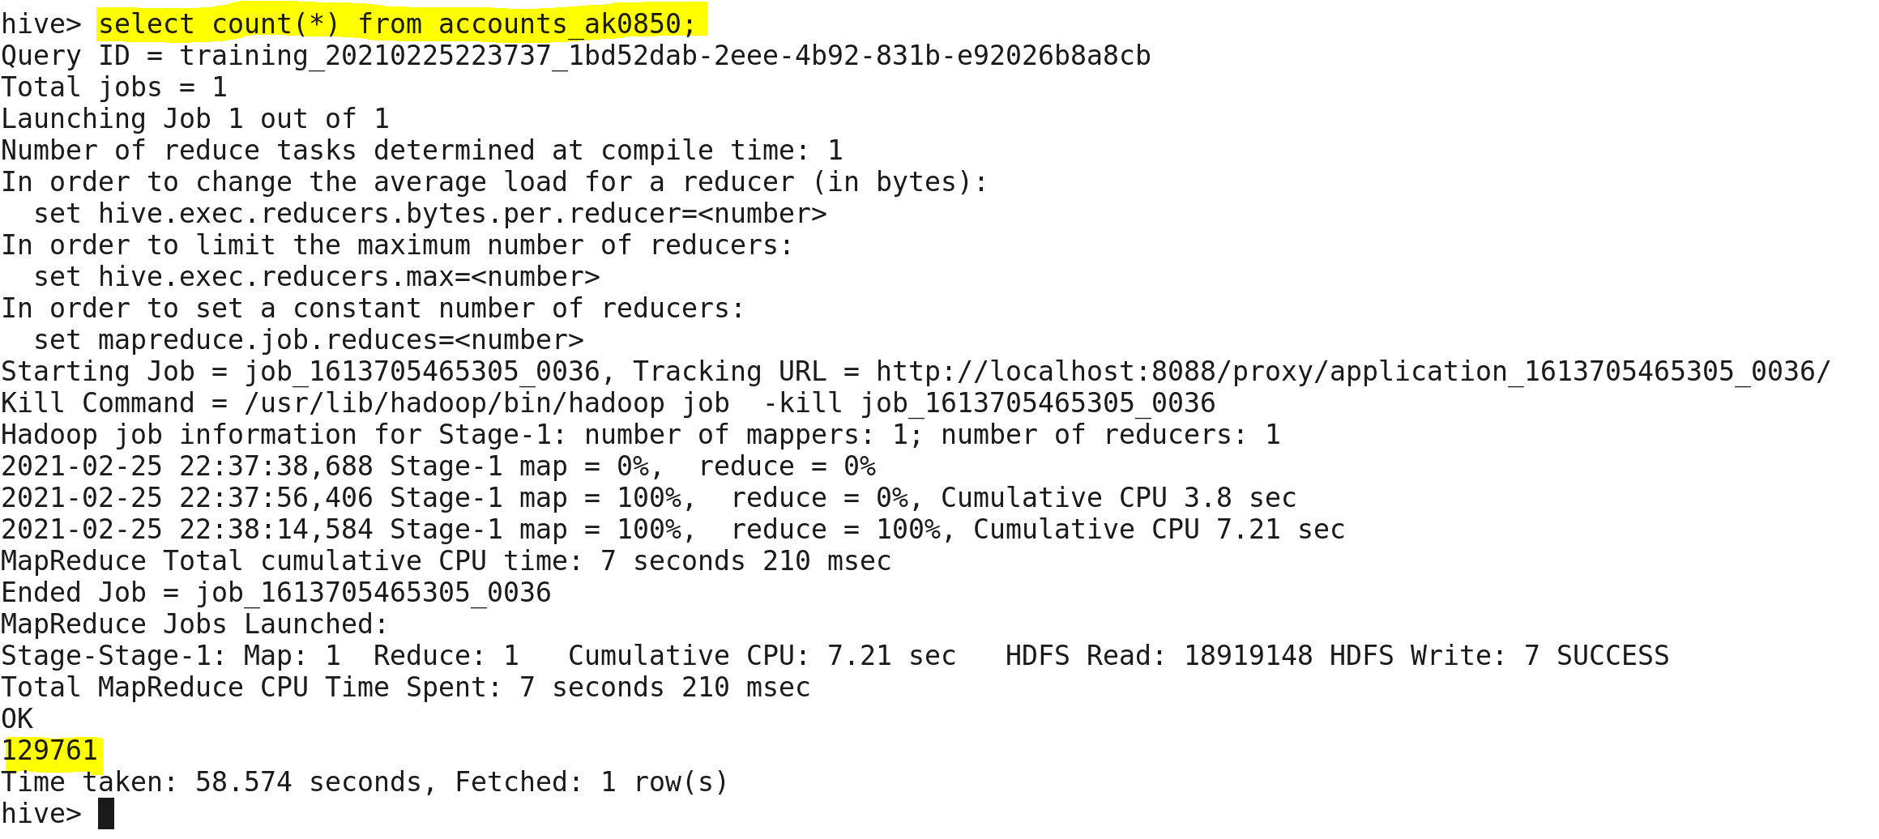

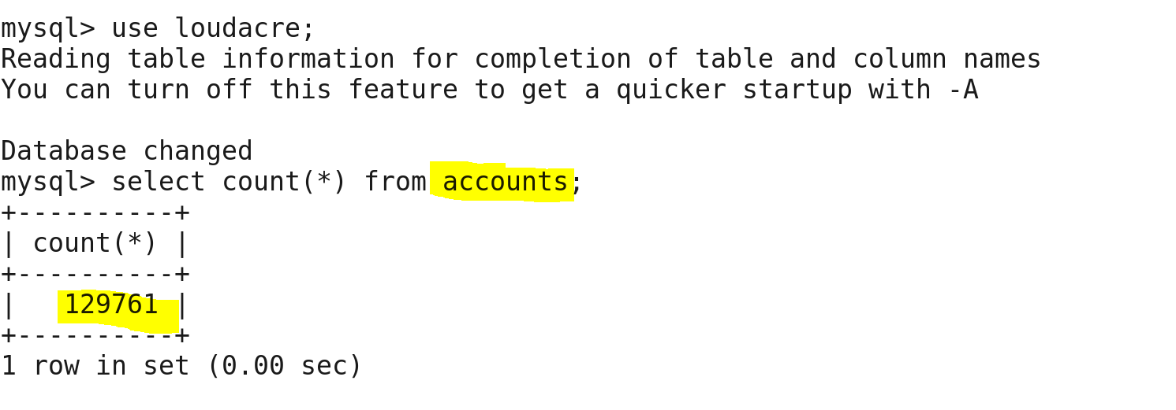

Only one data file has been created for accounts_ak0850 table in hive.

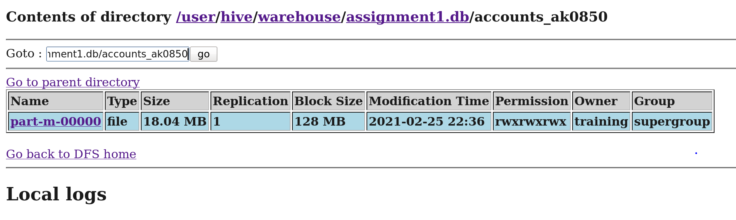

**Importing device table from loudacre database to hive under the name of device_ak0850 table.**

Below is the screenshot of sqoop command that creates hive table **device_ak0850** along with data in Hive.

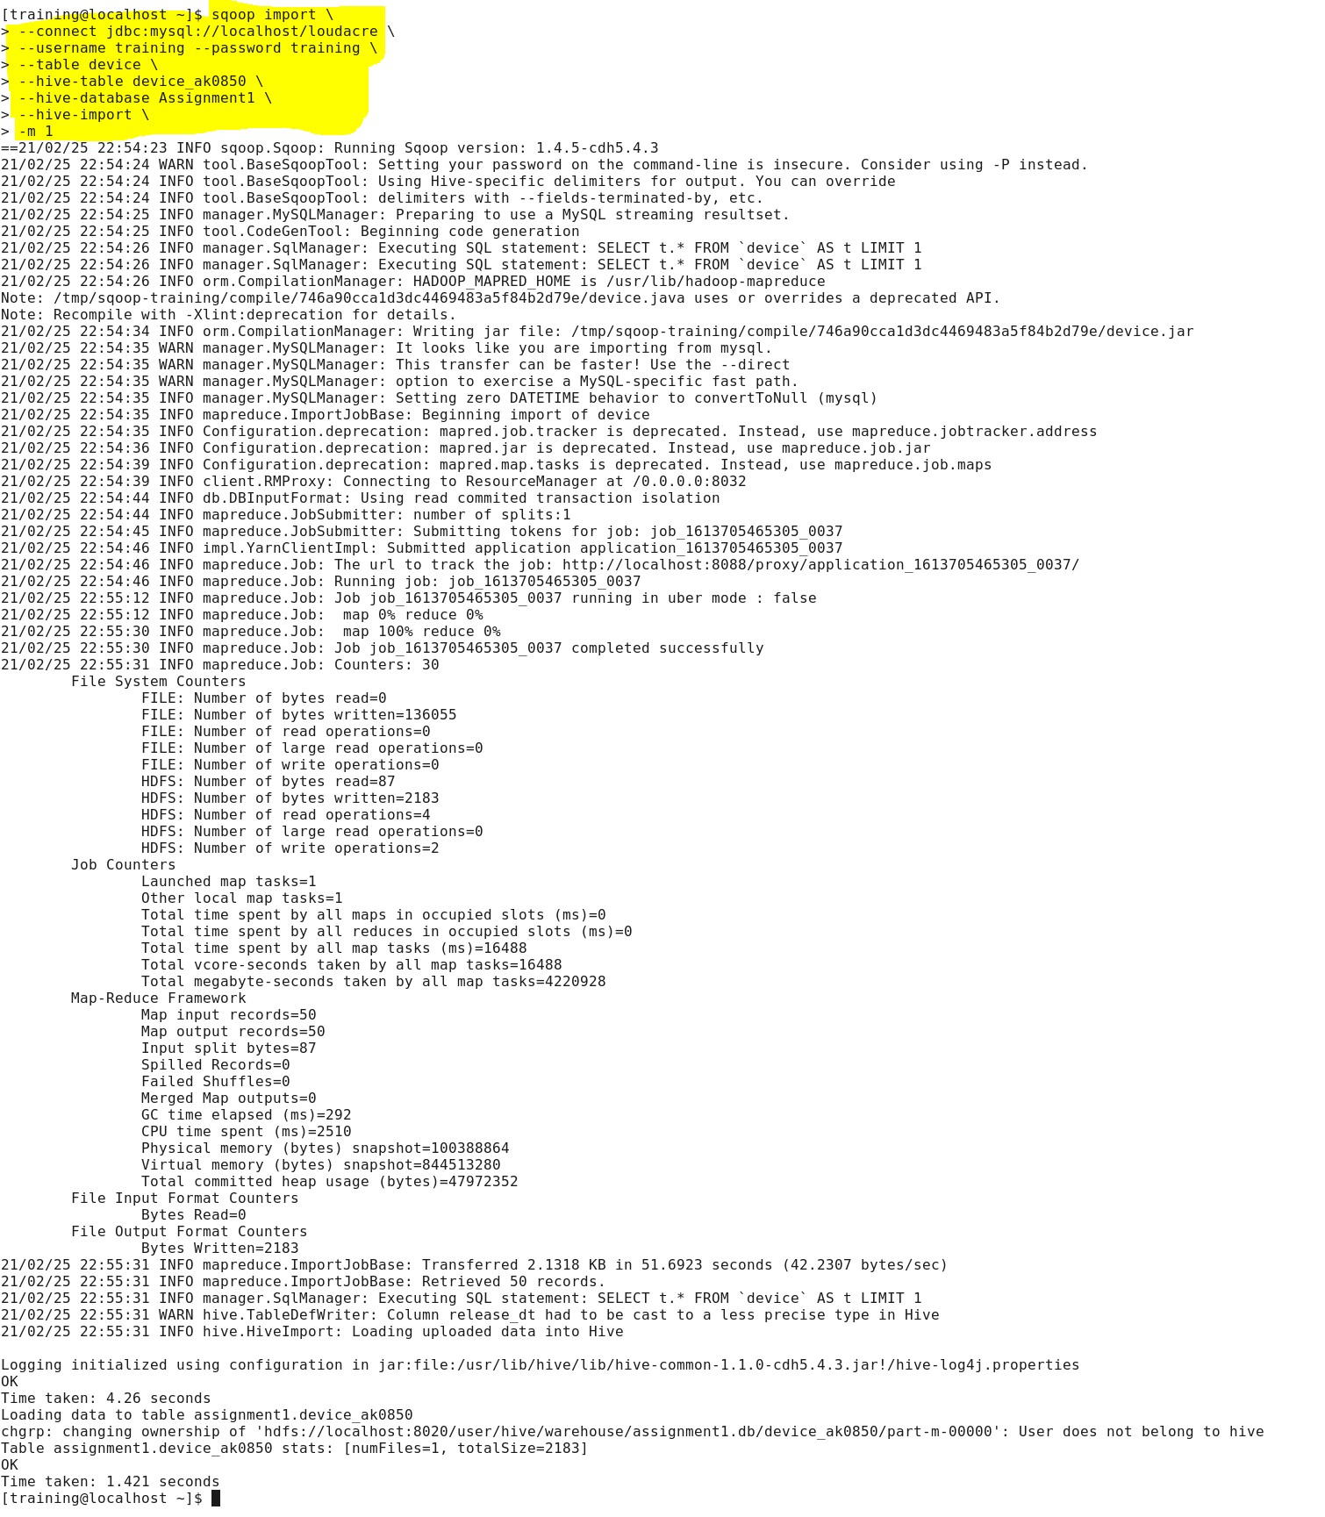

Validation of table creation device_ak0850 in Assignment1 hive database.

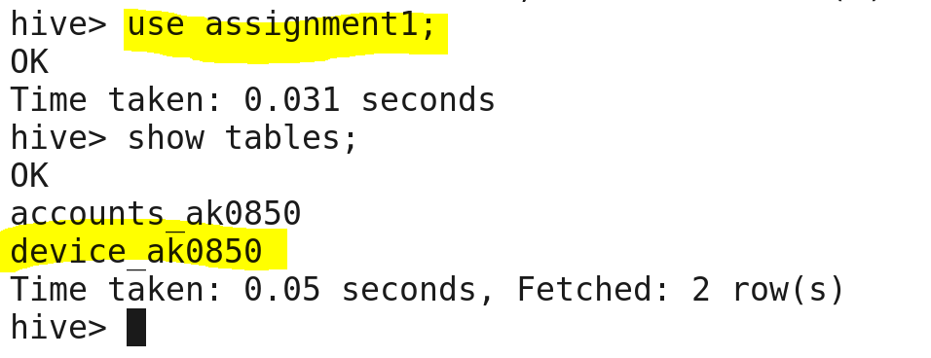

Validation of device_ak0850 table data in hive by displaying records.

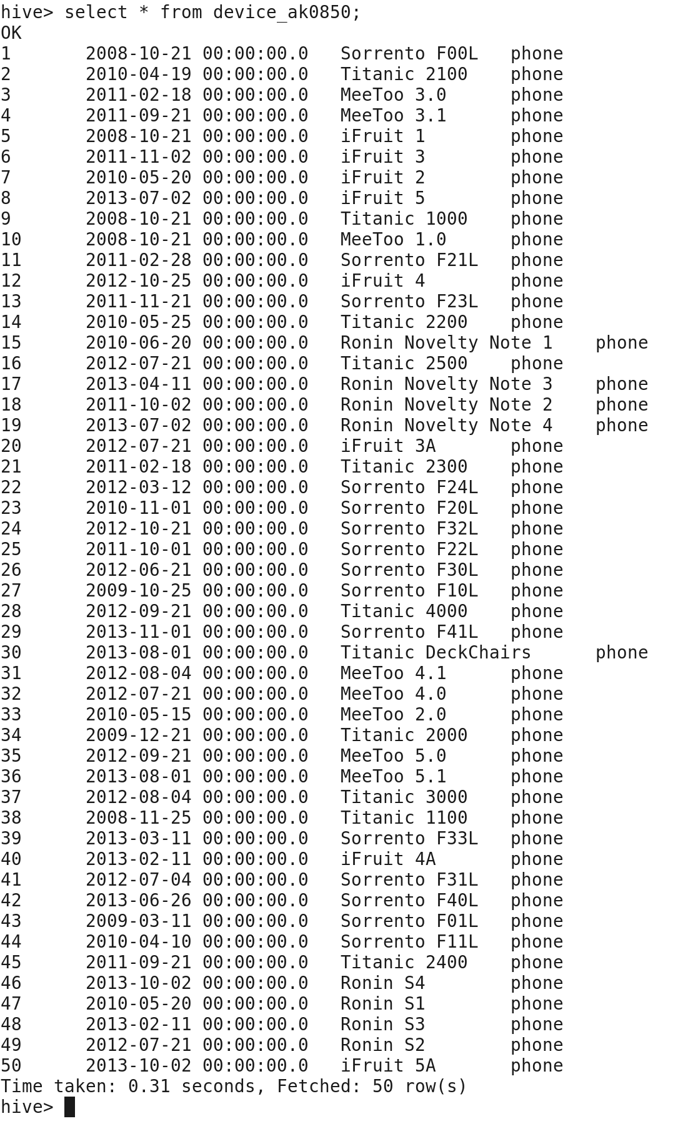

Validation of device_ak0850 table records count with the count of record in device table in sql.

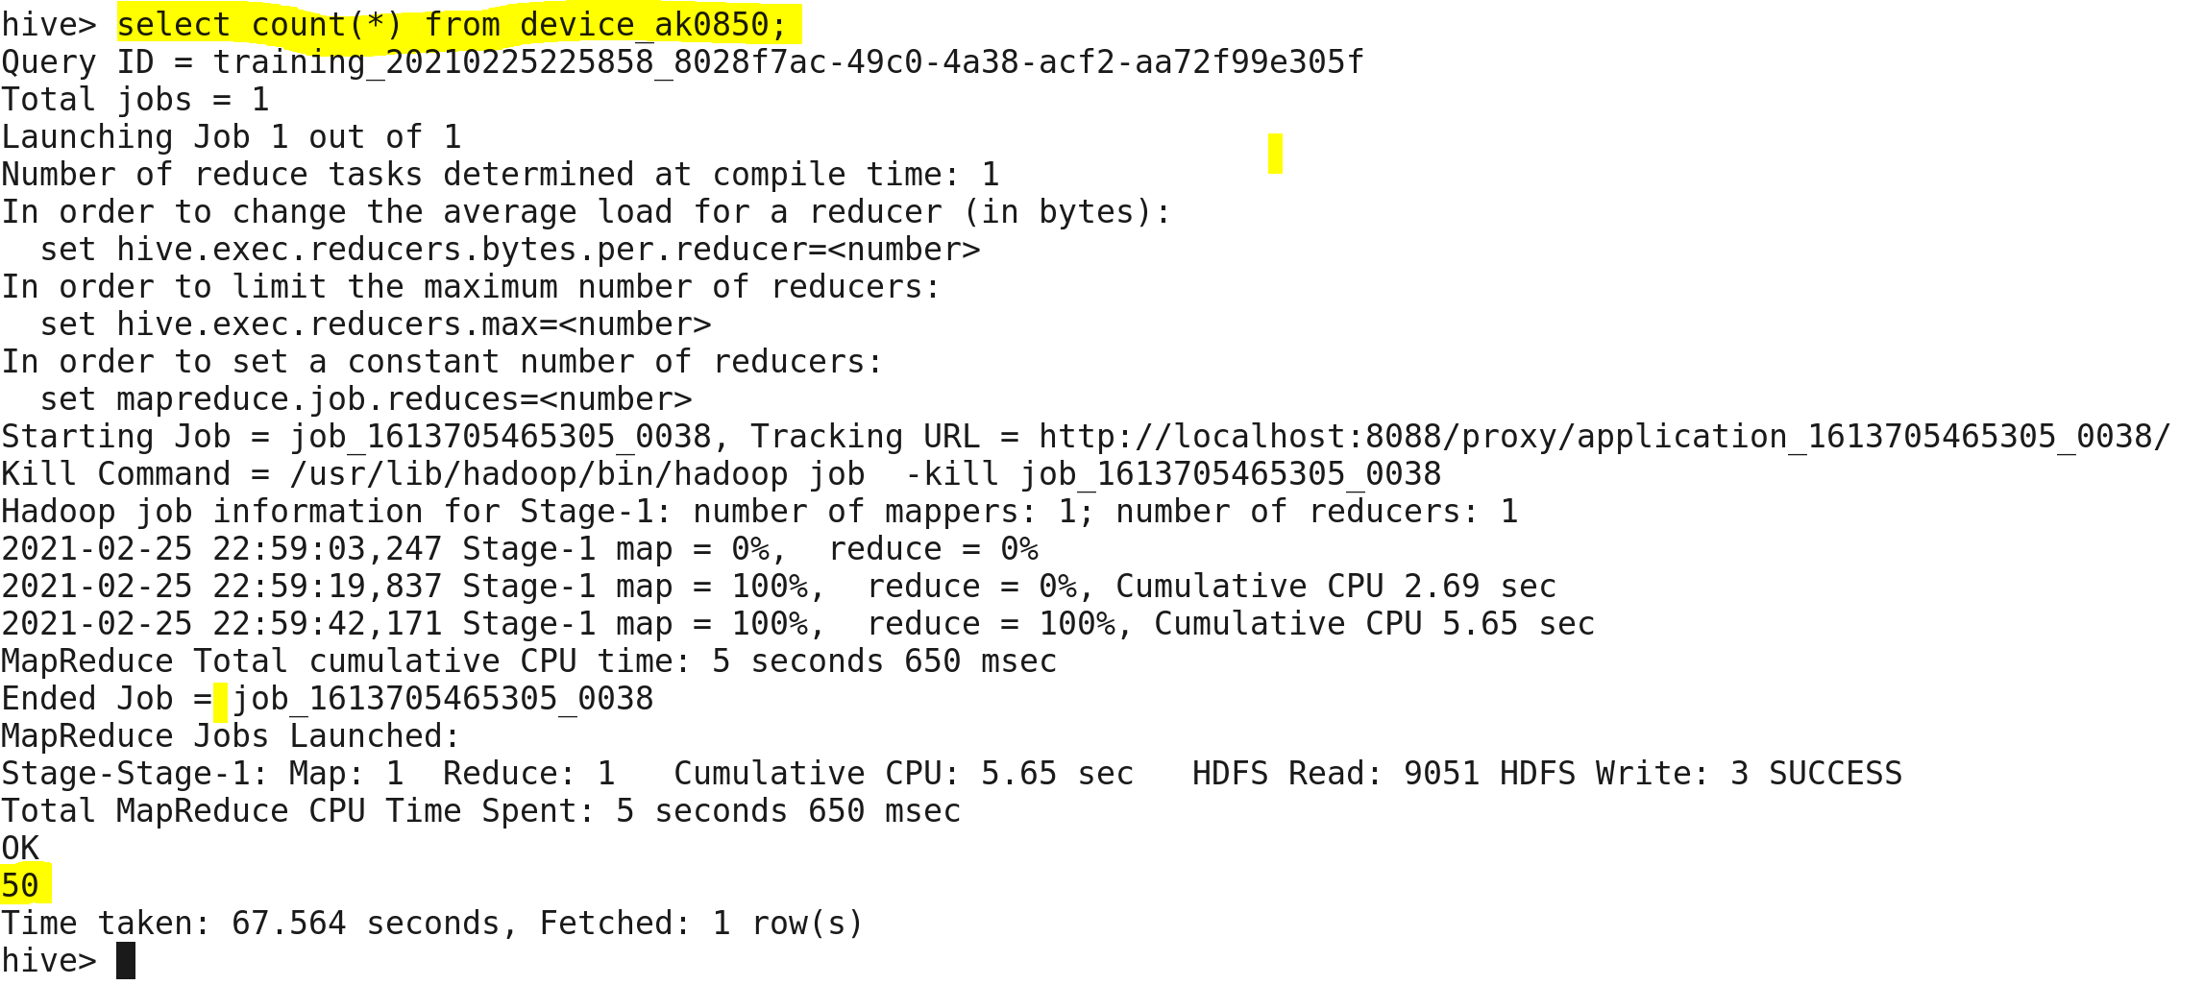

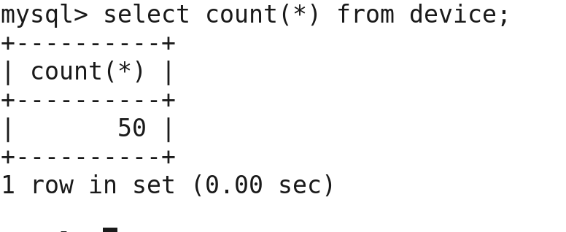

Only one data file has been created for device_ak0850 table in hive.

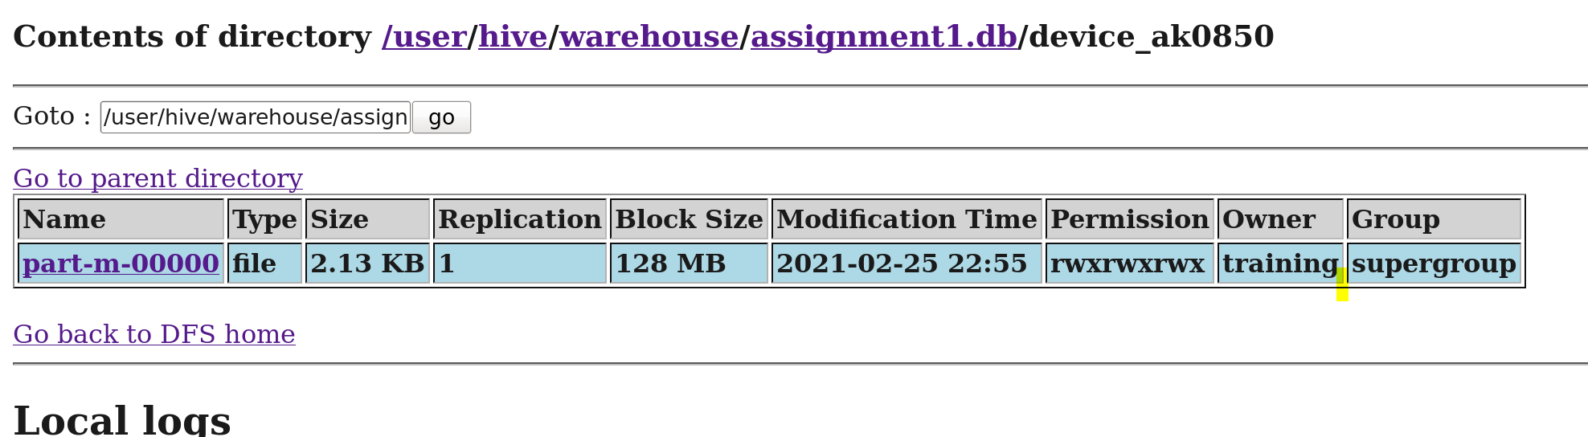

**Importing websitehit table from loudacre database to hive under the name of websitehit_ak0850 table.**

Below is the screenshot of sqoop command that creates hive table **websitehit_ak0850** along with data in Hive.

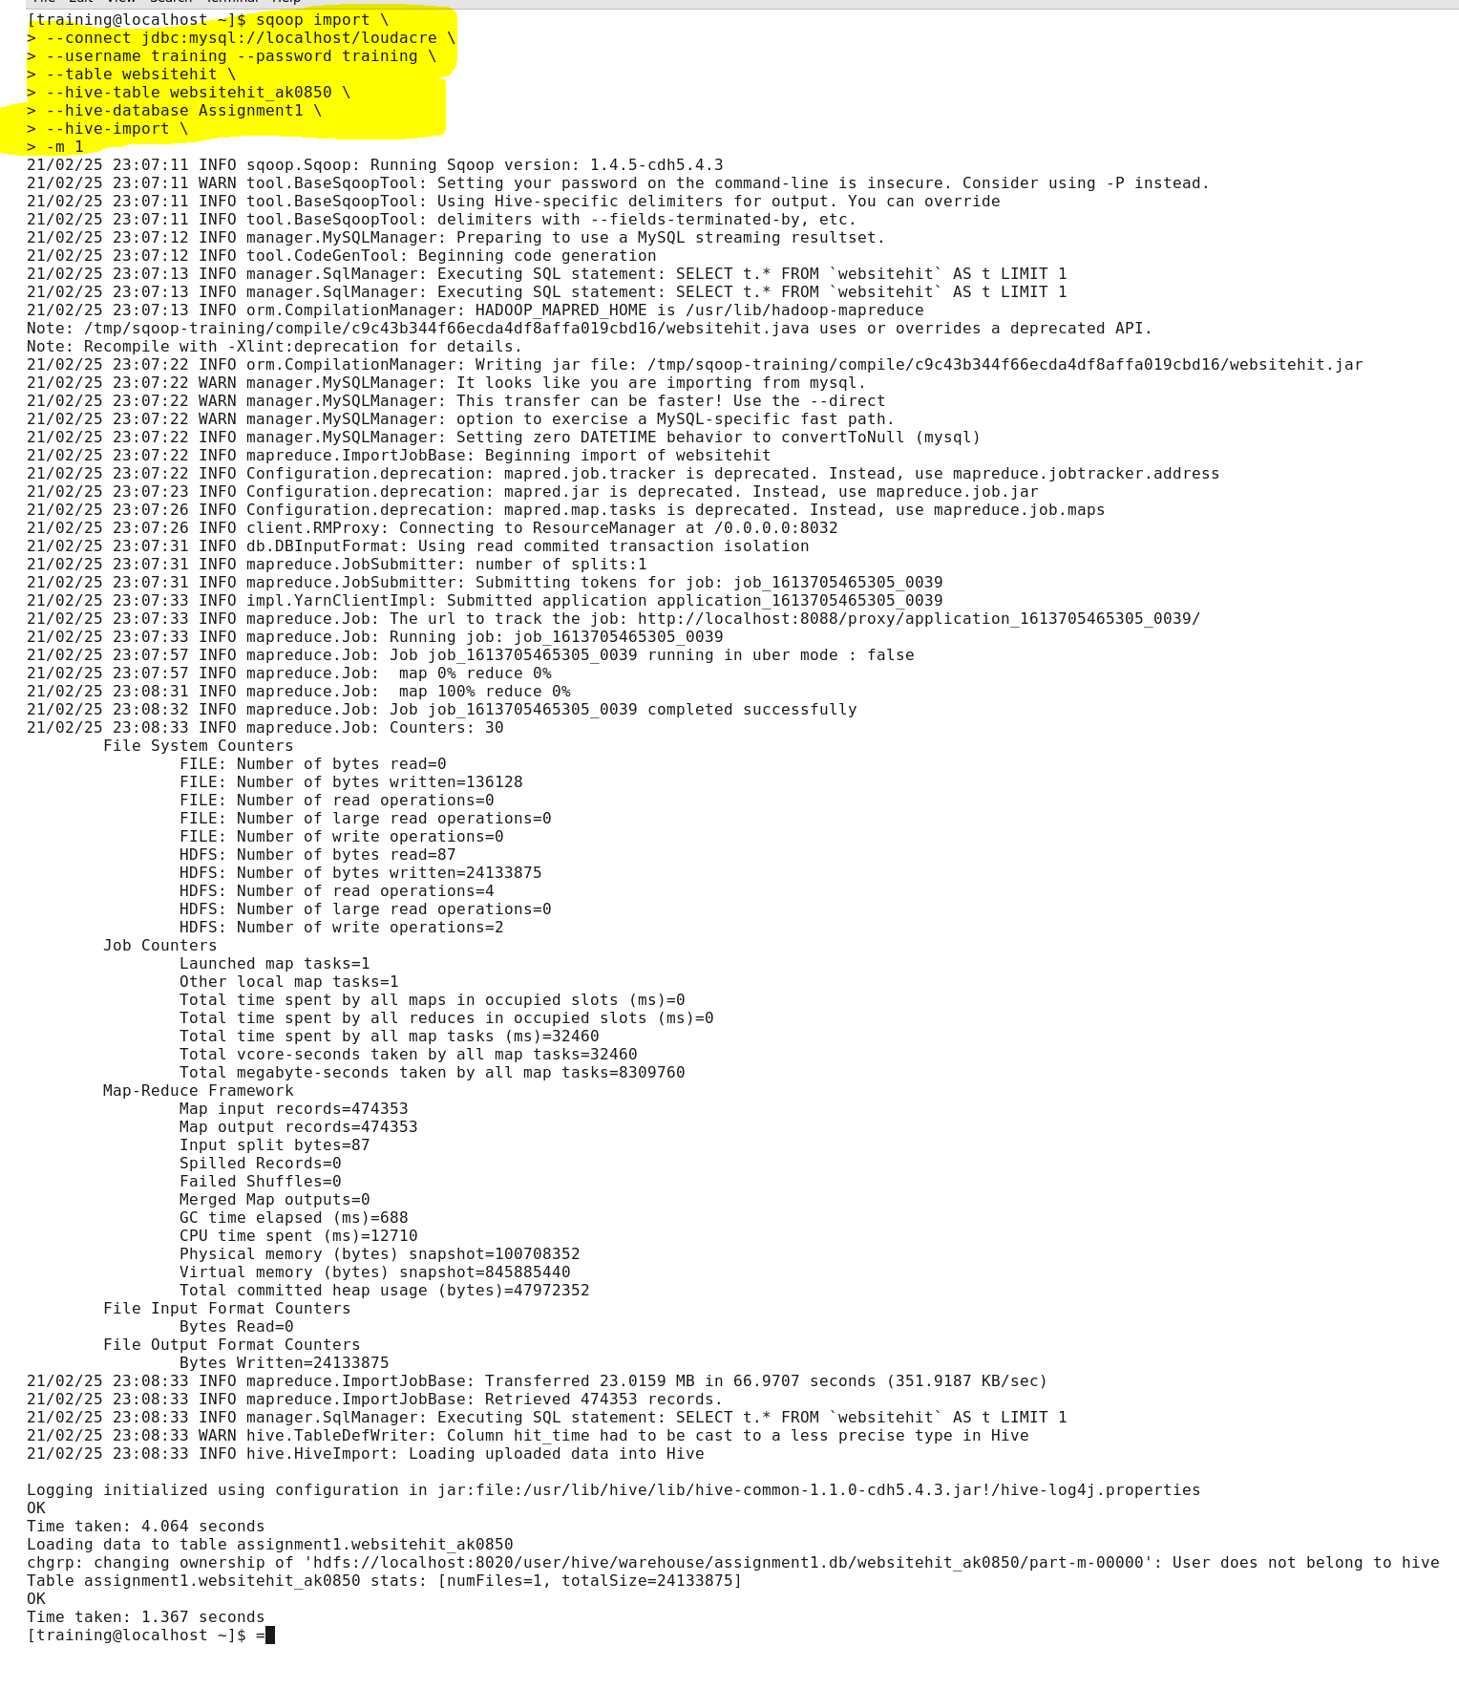

Validation of table creation websitehit_ak0850 in Assignment1 hive database.

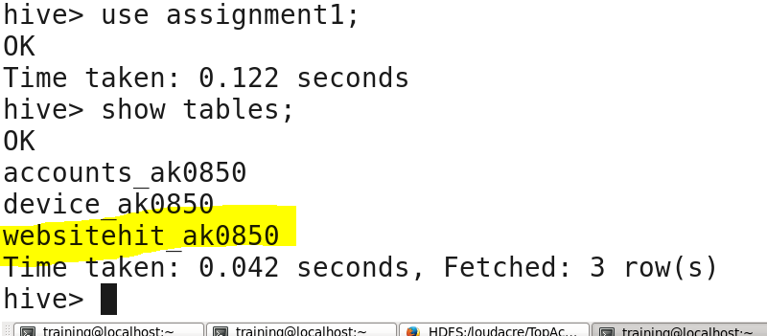

Validation of websitehit_ak0850 table data in hive by displaying 10 records.

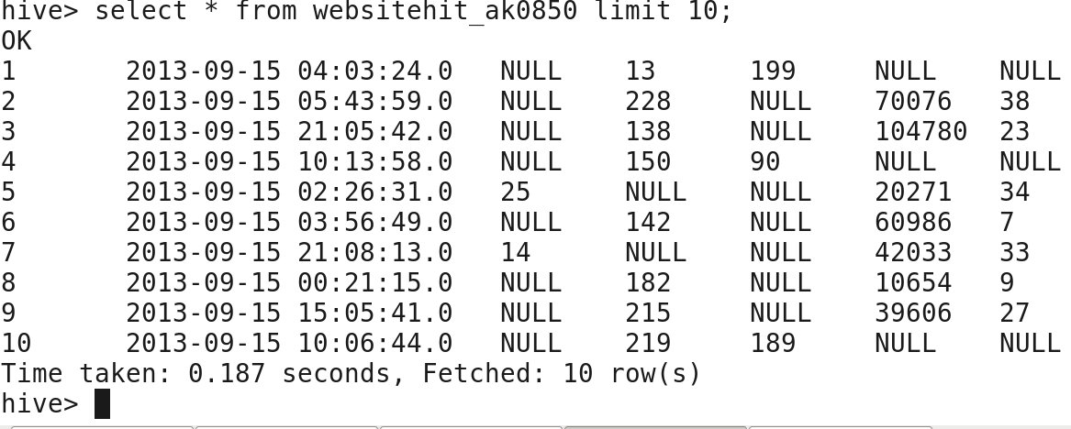

Validation of websitehit_ak0850 record count with the table websitehit record count in sql.’

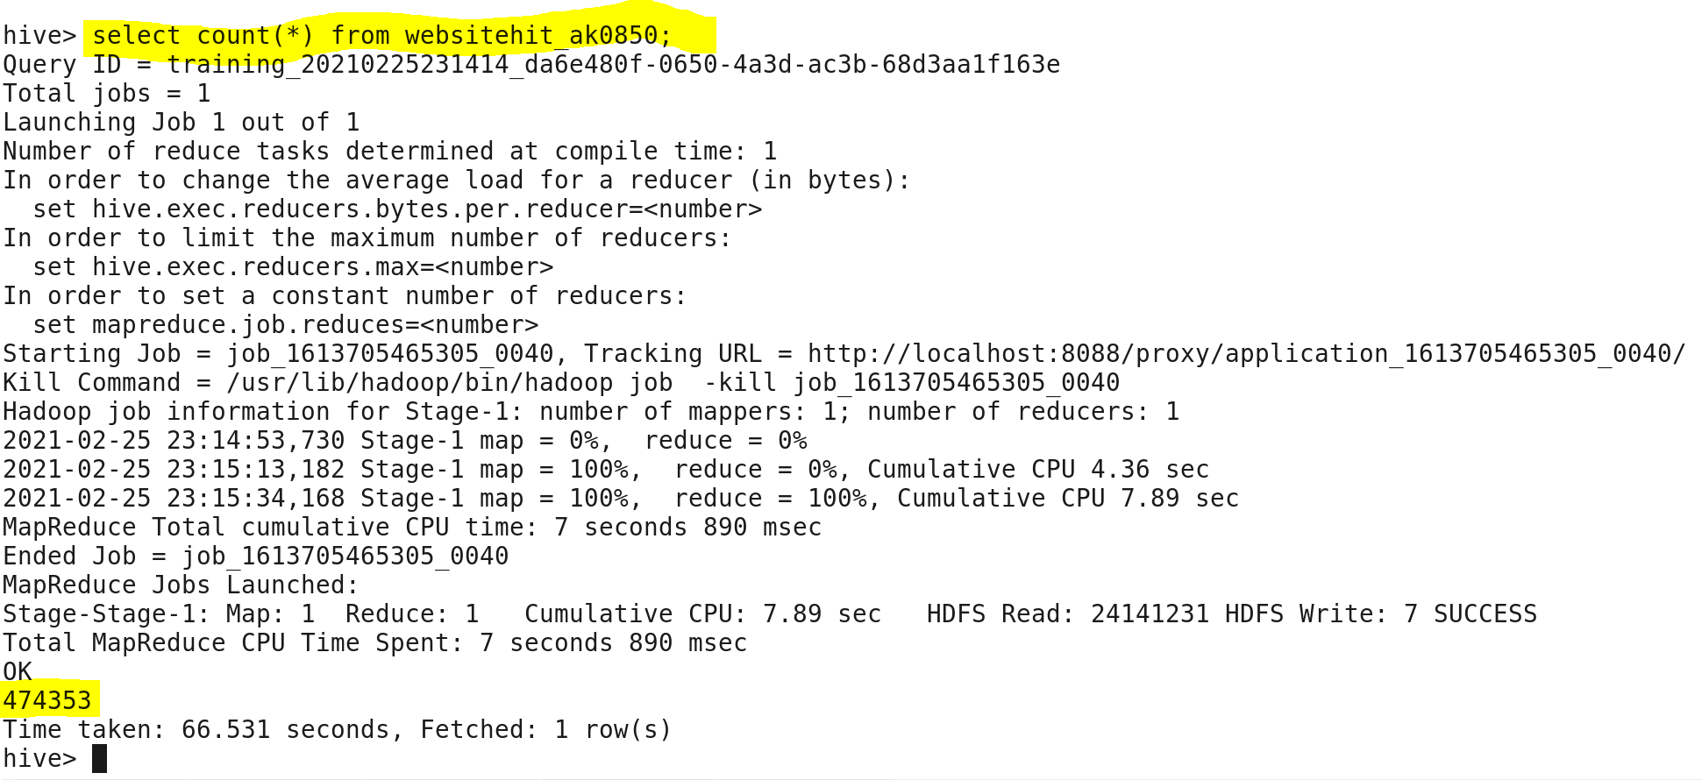

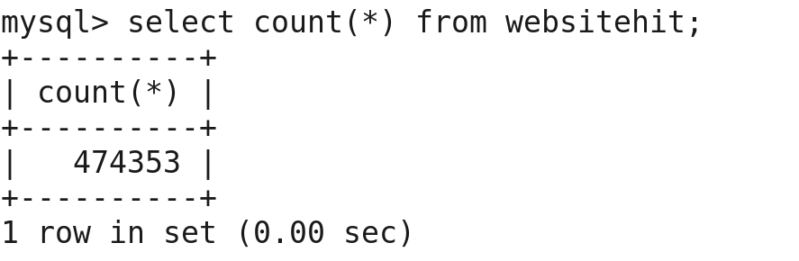

Only one data file has been created for websitehit_ak0850 table in hive.

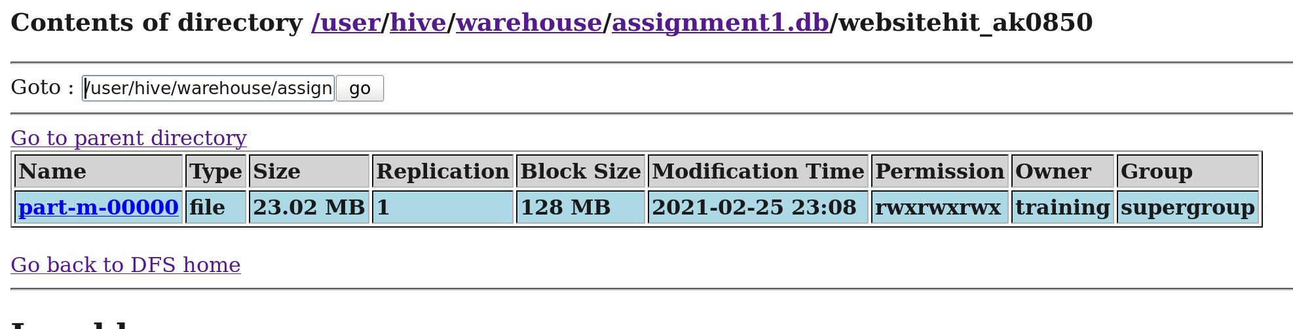

**Task 2: Query creation to get the records of accounts that have more than 30 website hits.**

Created a table in MySQL that holds the records of accounts which have more than 30 website hits.

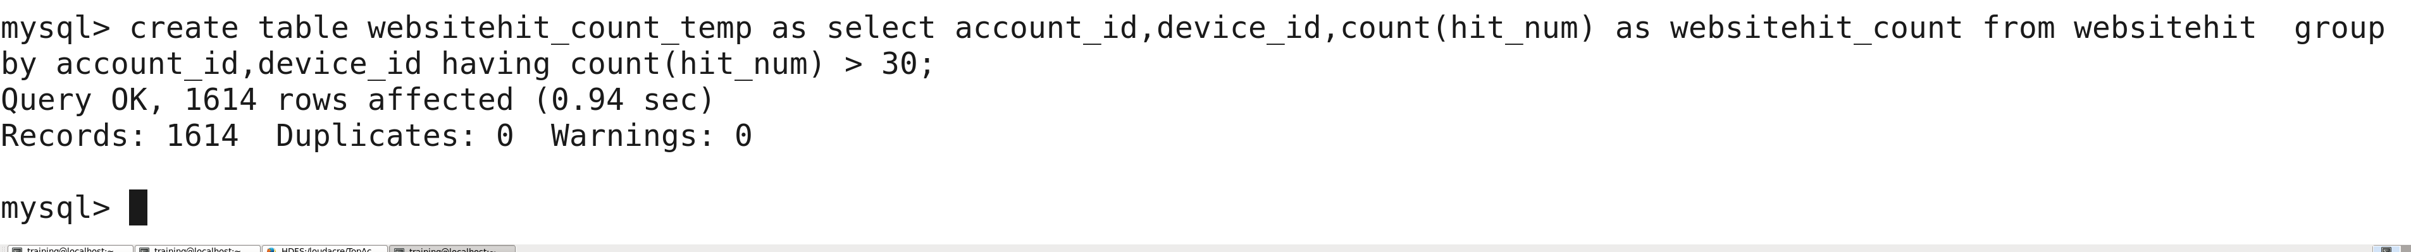

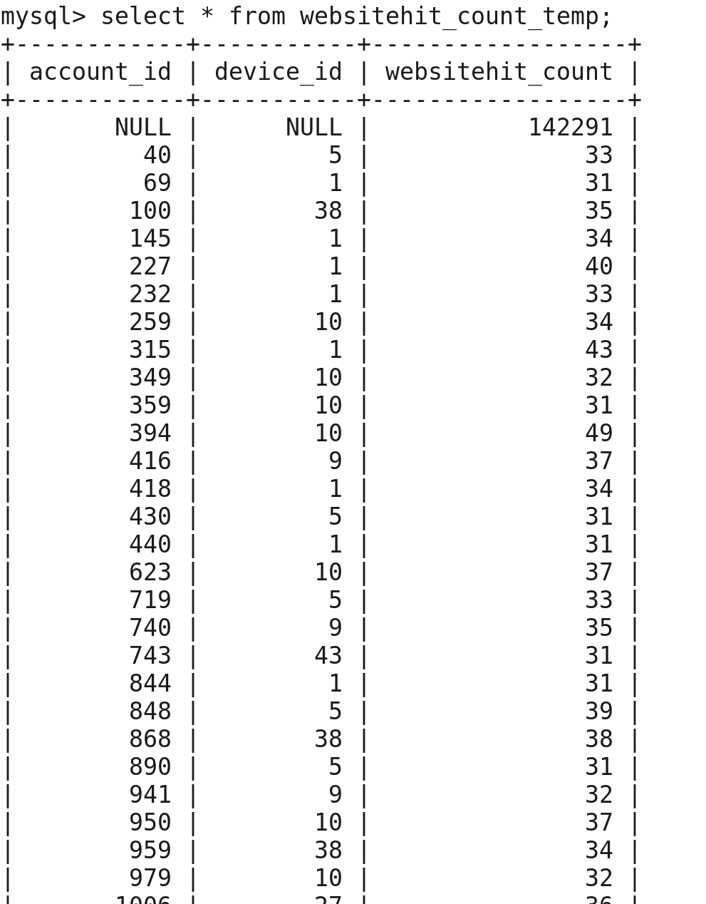

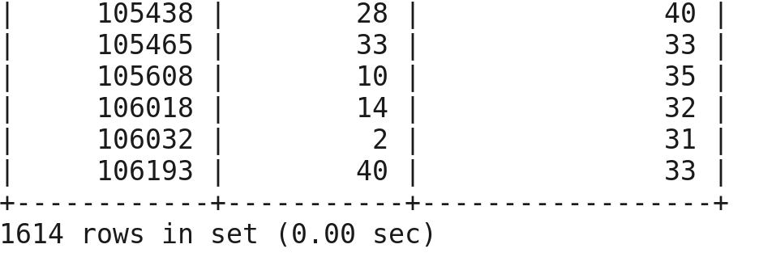

Below is the screenshot of query that fetches the records of accounts from table created in above step and stores the query results in HDFS file under **TopAccounts_ak0850 and retrieved 1613 records.**

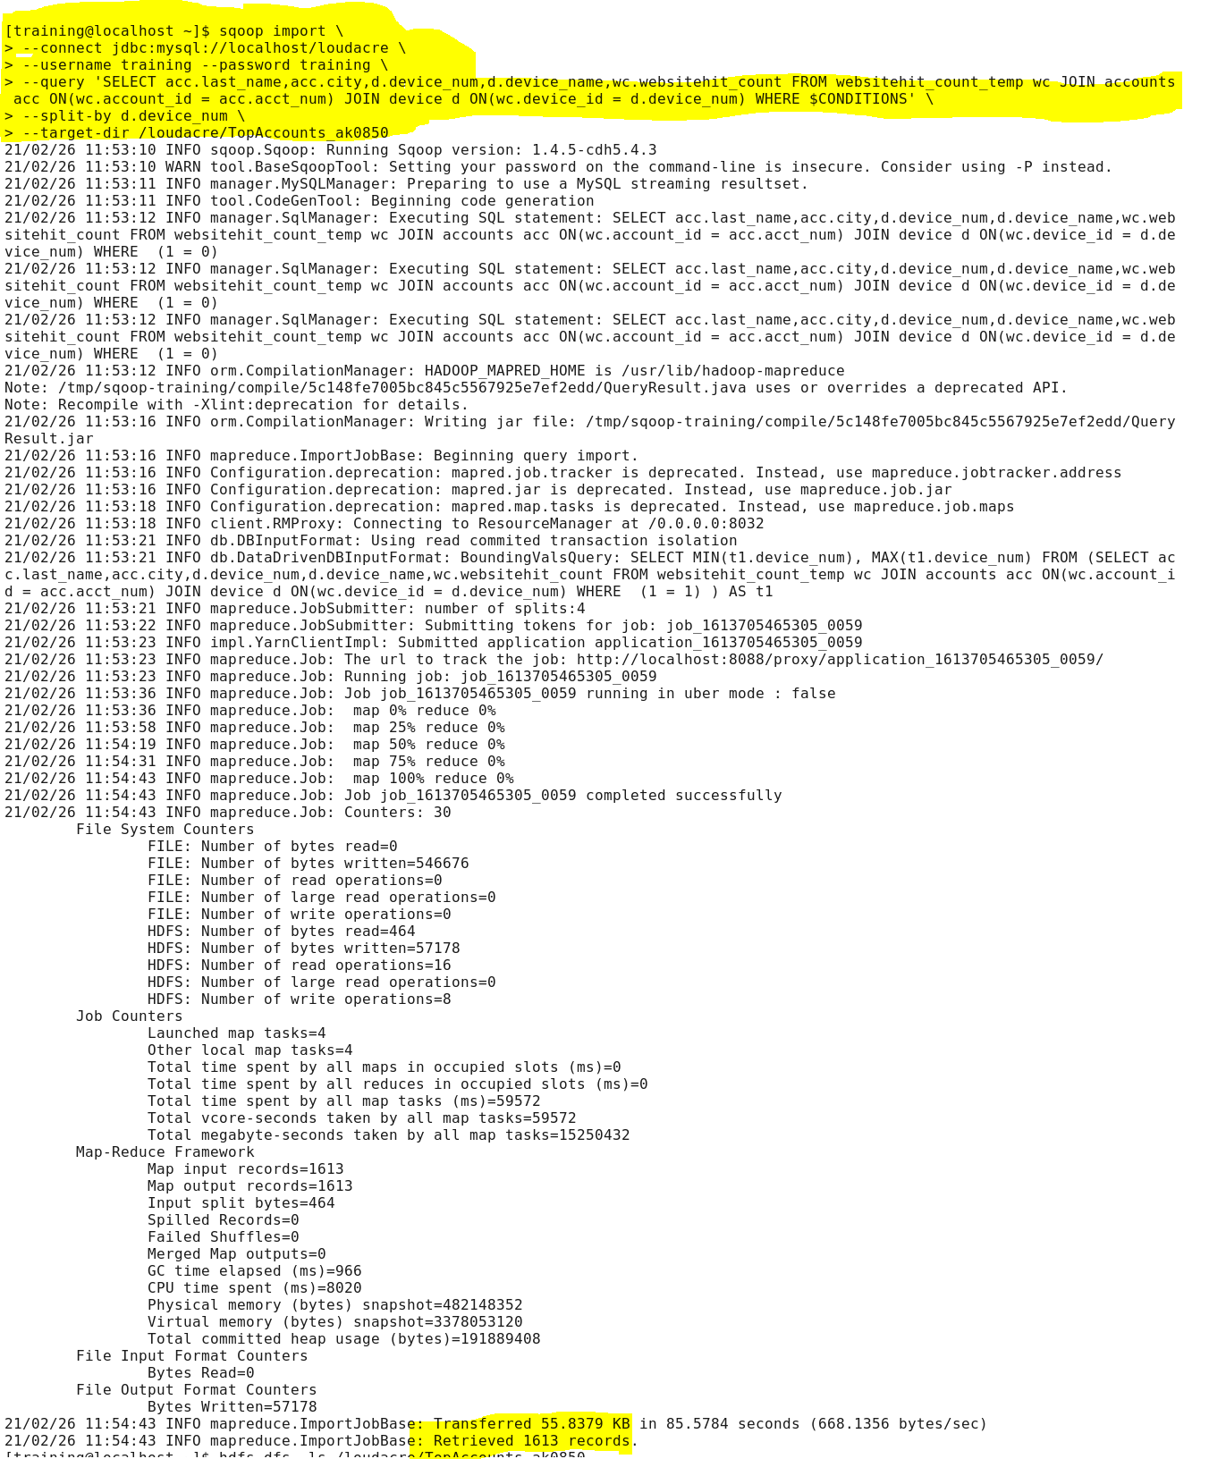

Validation of TopAccounts_ak0850 in HDFS and portal:

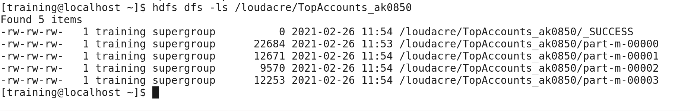

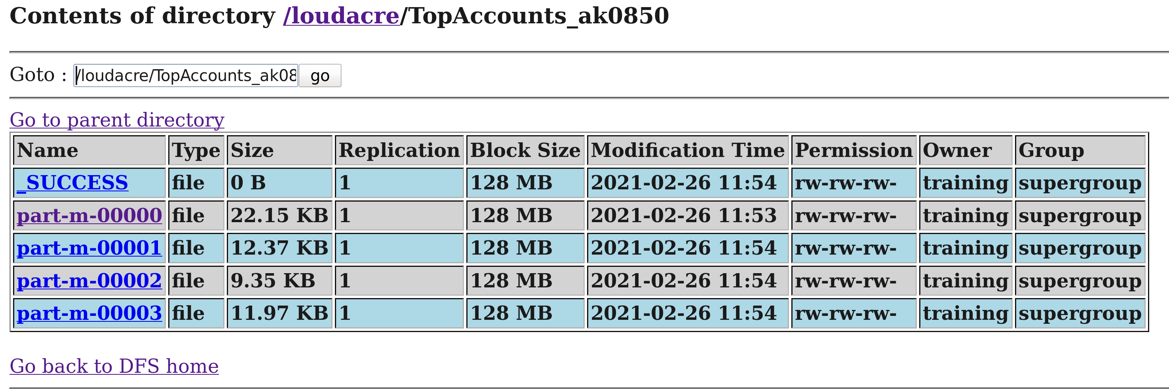

Validation of retrieval of data hdfs and portal:

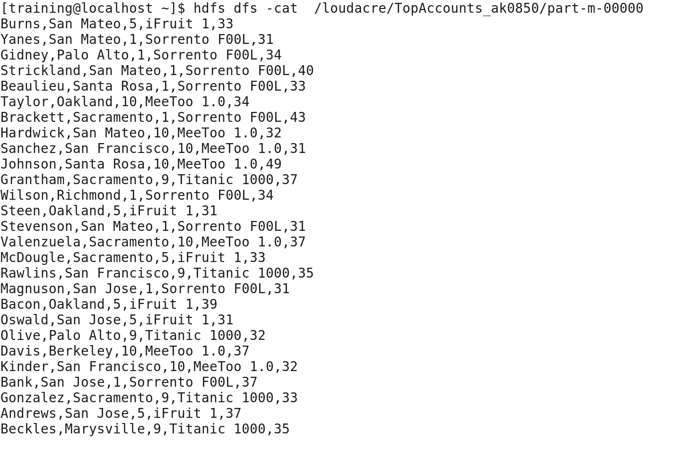

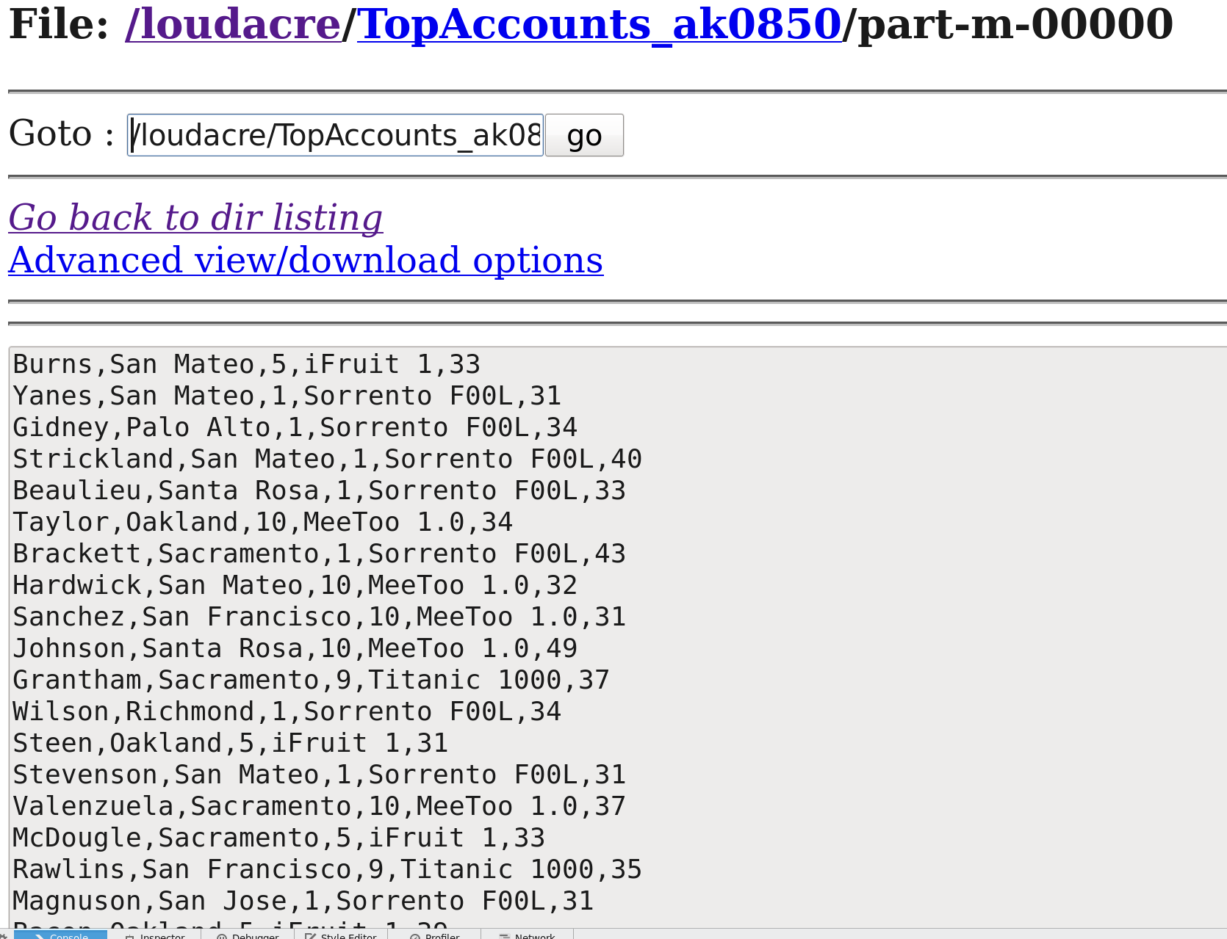

**Task 3: Exporting the data from TopAccounts_ak0850 to a new table in MySQL.**

Creation and validation of TopAccounts_ak0850_export table in MySQL loudacre database.

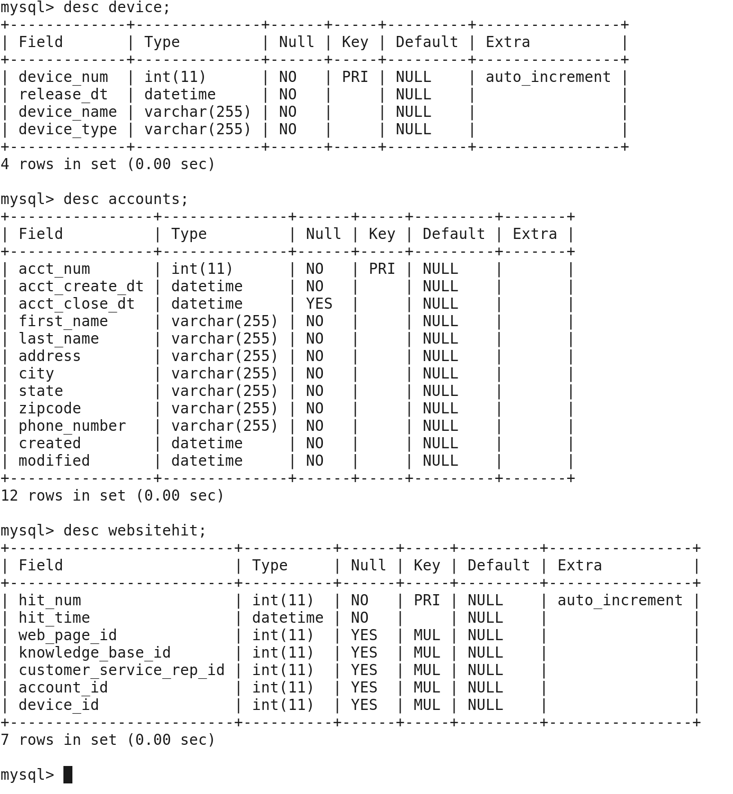

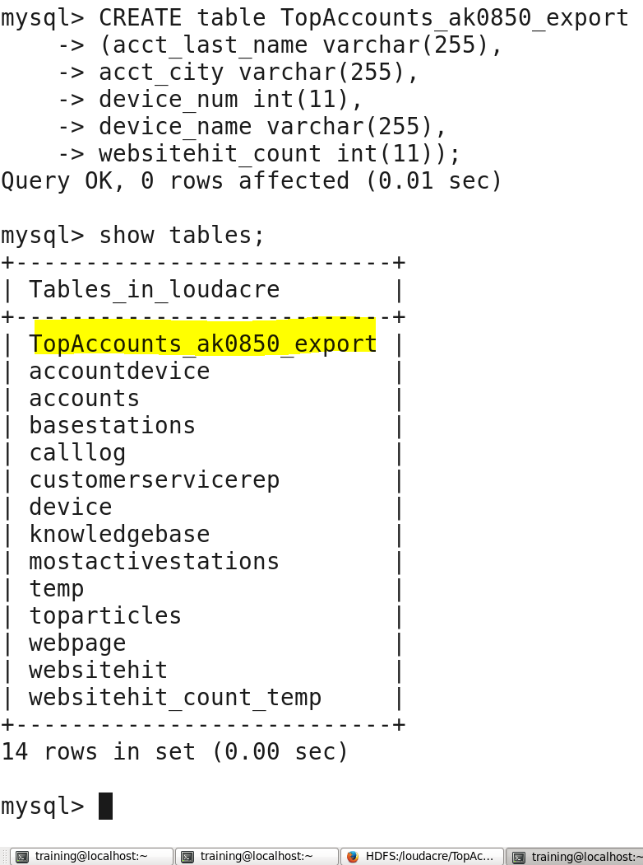

Below snippet of query exports the data i.e., 1613 records from **TopAccounts_ak0850** file created in task2 to a new table **“TopAccounts_ak0850_export”** in MySQL.

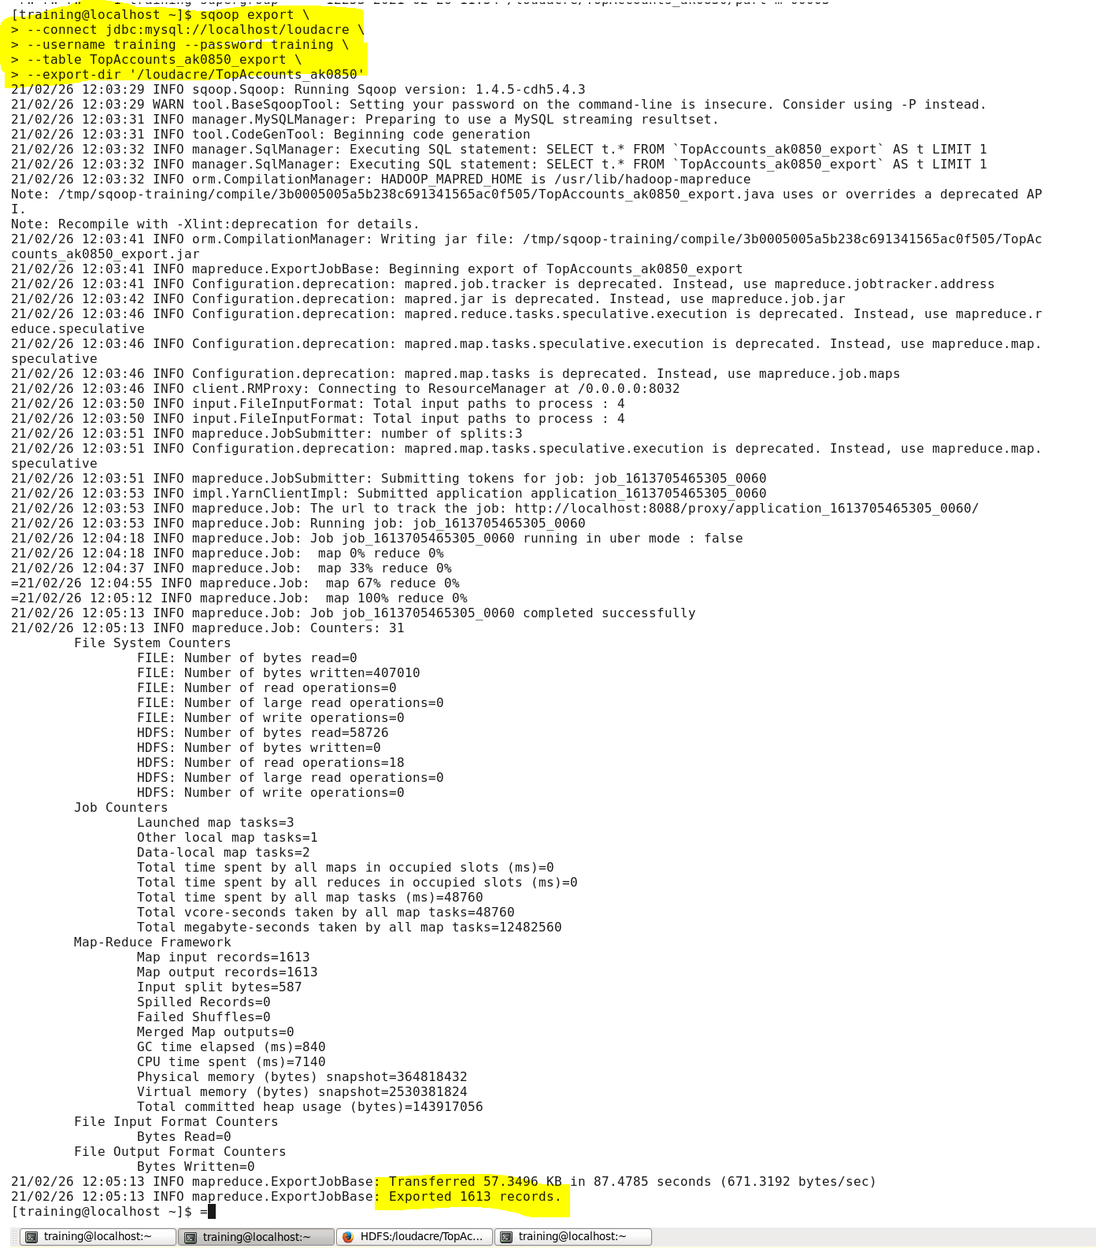

Validation of TopAccounts_ak0850 HDFS file data in MySQL using below snippet of MySQL query along with its data of 10 records.

